PROJECTS

DEPARTMENTS

1…\* 1…\*

1

1\*\*\*

\*\*

1\*\*\*

EMPLOYEE

1

1

\*\*

1\*\*\*

DETAILS

Entity framework

install-package entityframework -version 6.2

CREATE MYDBCONTEXT CLASS

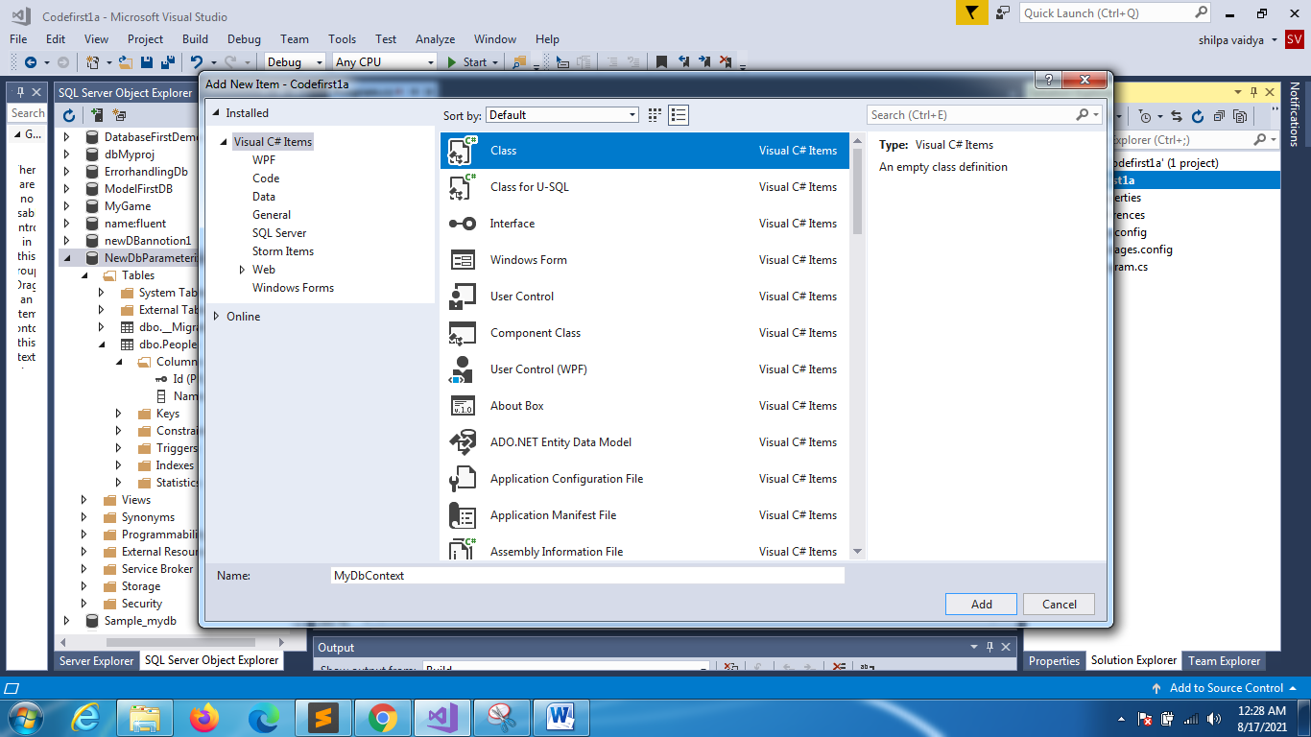

using System;

using System.Data.Entity;

namespace Codefirst1a

{

    class MyDbContext:DbContext

    {

        public MyDbContext():base("EmpDetails1")

        {

        }

    }

}

Domain class

Department.cs

using System;

namespace Codefirst1a

{

    class Department

    {

        public int DepartmentID { get; set; }//pk

        public string DeptName { get; set; }

        public string Location { get; set; }

        public int noofproj { get; set; }

        //navigation prop

    }

}

Employee.cs

using System;

using System.Collections.Generic;

using System.Linq;

using System.Text;

using System.Threading.Tasks;

namespace Codefirst1a

{

    class Employee

    {

        public int EmployeeId { get; set; }

        public string EmpName { get; set; }

        public string Phone { get; set; }

        public int Age { get; set; }

//navigational prop

    }

}

Details.cs

using System;

using System.Collections.Generic;

using System.Linq;

using System.Text;

using System.Threading.Tasks;

namespace Codefirst1a

{

    class Details

    {

        public int StudentId { get; set; }

        public string Address { get; set; }

        public string City { get; set; }

        public string State { get; set; }

        //navigational properties

    }

}

Project.cs

using System;

using System.Collections.Generic;

using System.Linq;

using System.Text;

using System.Threading.Tasks;

namespace Codefirst1a

{

    class Project

    {

        public int ProjectId { get; set; }

        public string ProjName { get; set; }

        public string ClientName { get; set; }

        //navigational prop

    }

}

1 Dept Id ----🡪 many employees

Hence as per the rule it should be public virtual of type ICollection of Employee name pluralized,

using System;

using System.Collections.Generic;

using System.Linq;

using System.Text;

using System.Threading.Tasks;

namespace Codefirst1a

{

    class Department

    {

        public int DepartmentID { get; set; }//pk

        public string DeptName { get; set; }

        public string Location { get; set; }

        public int noofproj { get; set; }

        //navigation prop

        public virtual ICollection<Employee> Employees { get; set; }

    }

}

1 Emp -🡪will have 1 Dept

using System;

using System.Collections.Generic;

using System.Linq;

using System.Text;

using System.Threading.Tasks;

namespace Codefirst1a

{

    class Employee

    {

        public int EmployeeId { get; set; }

        public string EmpName { get; set; }

        public string Phone { get; set; }

        public int Age { get; set; }

        //navigation

//1 emp 1 dept

        public virtual Department Department { get; set; }

    }

}

1 Emp has 1 Details(1to 1)

using System;

using System.Collections.Generic;

using System.Linq;

using System.Text;

using System.Threading.Tasks;

namespace Codefirst1a

{

    class Employee

    {

        public int EmployeeId { get; set; }

        public string EmpName { get; set; }

        public string Phone { get; set; }

        public int Age { get; set; }

        //navigation

        public virtual Department Department { get; set; }

        public virtual Details EmpDetails { get; set; }

    }

}

Similarly 1details🡪 1 employee

using System;

using System.Collections.Generic;

using System.Linq;

using System.Text;

using System.Threading.Tasks;

namespace Codefirst1a

{

    class Details

    {

        public int StudentId { get; set; }

        public string Address { get; set; }

        public string City { get; set; }

        public string State { get; set; }

        //navigational properties

        public virtual Employee Employee { get; set; }

    }

}

Many to many between department and projects

using System;

namespace Codefirst1a

{

    class Department

    {

        public int DepartmentID { get; set; }//pk

        public string DeptName { get; set; }

        public string Location { get; set; }

        public int noofproj { get; set; }

        //navigation prop

        public virtual ICollection<Employee> Employees { get; set; }

        public virtual ICollection<Project> Projects { get; set; }

    }

}

In project class

using System;

using System.Collections.Generic;

using System.Linq;

using System.Text;

using System.Threading.Tasks;

namespace Codefirst1a

{

    class Project

    {

        public int ProjectId { get; set; }

        public string ProjName { get; set; }

        public string ClientName { get; set; }

        //navigational prop

        public virtual ICollection<Department> Departments { get; set; }

    }

}

Mydbcontext

using System;

using System.Data.Entity;

namespace Codefirst1a

{

    class MyDbContext:DbContext

    {

        public MyDbContext():base("EmpDetails1")

        {

        }

        public virtual DbSet<Department> Departments { get; set; }

        public virtual DbSet<Employee> Employees { get; set; }

        public virtual DbSet<Project> Projects { get; set; }

        public virtual DbSet<Details> Details { get; set; }

    }

}

Program.cs

using System;

using System.Collections.Generic;

using System.Linq;

using System.Text;

using System.Threading.Tasks;

namespace Codefirst1a

{

    class Program

    {

        static void Main(string[] args)

        {

            MyDbContext db = new MyDbContext();

            try

            {

                Department dept = new Department();

                dept.DepartmentID = 11;

                dept.DeptName = "ROBOTICS";

                dept.noofproj = 12;

                dept.Location = "Bangalore";

                db.Departments.Add(dept);

                db.SaveChanges();

                Console.WriteLine("db created");

            }

            catch(Exception e)

            {

                Console.WriteLine(e.Message);

            }

        }

    }

}

ERROR

One or more validation errors were detected during model generation:

Codefirst1a.Details: : EntityType 'Details' has no key defined. Define the key f

or this EntityType.

Details: EntityType: EntitySet 'Details' is based on type 'Details' that has no

keys defined.

Press any key to continue . . .

Temporarily make changes

Details.cs

using System;

using System.Collections.Generic;

using System.Linq;

using System.Text;

using System.Threading.Tasks;

namespace Codefirst1a

{

    class Details

    {

        public int StudentId { get; set; }

        public string Address { get; set; }

        public string City { get; set; }

        public string State { get; set; }

        //navigational properties

        //public virtual Employee Employee { get; set; }

    }

}

Employee.cs

using System;

using System.Collections.Generic;

using System.Linq;

using System.Text;

using System.Threading.Tasks;

namespace Codefirst1a

{

    class Employee

    {

        public int EmployeeId { get; set; }

        public string EmpName { get; set; }

        public string Phone { get; set; }

        public int Age { get; set; }

        //navigation

        public virtual Department Department { get; set; }

       // public virtual Details EmpDetails { get; set; }

    }

}

Dbcontext

using System;

using System.Data.Entity;

namespace Codefirst1a

{

    class MyDbContext:DbContext

    {

        public MyDbContext():base("EmpDetails1")

        {

        }

        public virtual DbSet<Department> Departments { get; set; }

        public virtual DbSet<Employee> Employees { get; set; }

        public virtual DbSet<Project> Projects { get; set; }

        //public virtual DbSet<Details> Details { get; set; }

    }

}

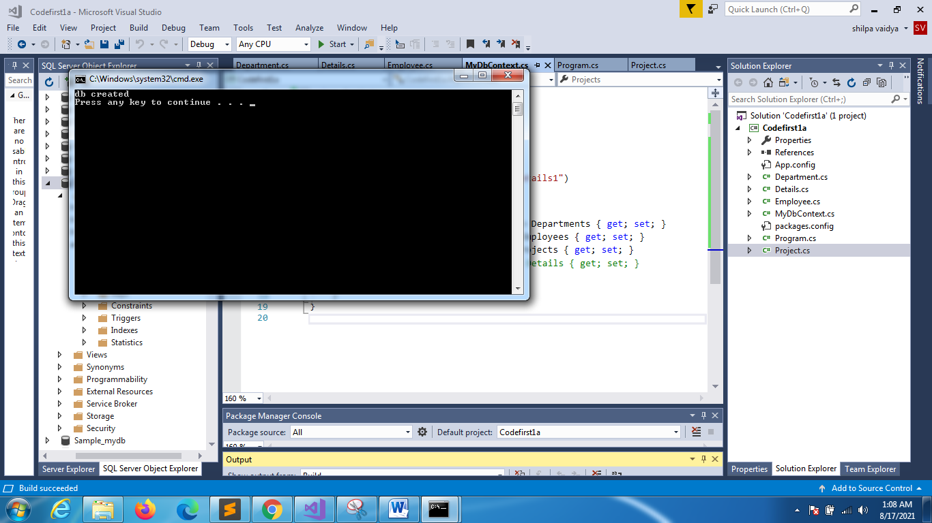

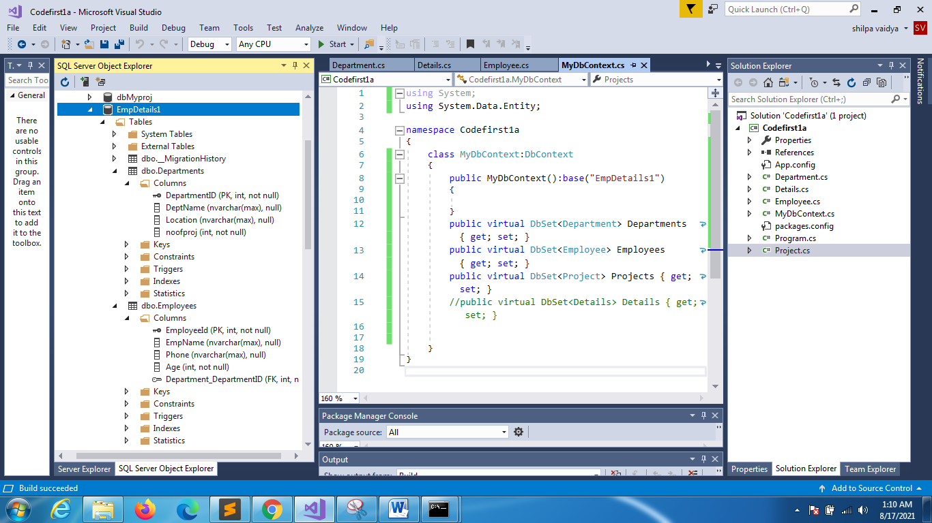

By default primary key is autoincremented